 | 14.3.3 Editors - Video Sequence Editor - Sidebar - Sequencer - Strip tab
Table of content
Detailed table of content 2
Strip Tab 5
Strip tab header 5
Compositing Panel 6
Transform Panel 6
Filter 6
Position X 6
Y 6
Rotation 6
Mirror 6
Video Panel 6
Color Panel 7
Saturation 7
Multiply 7
Convert to Float 7
Sound Panel 7
Volume 7
Pitch 7
Pan 7
Mono 7
Display Waveform 7
Time Panel 8
Lock 8
Channel 8
Start 8
Duration 8
End 8
Scene Panel 8
Scene Property 8
Input 9
Mask Panel 10
Mask Property 10
Effect Strip Panel 10
Effect strip type Color Mix 10
Effect strip type Text 11
Effect strip type Gaussian Blur 13
Effect strip type Multicam 13
Effect strip type Speed Control 13
Effect strip type Color 14
Effect strip type Transform 14
Effect strip type Glow 15
Effect strip type Wipe 15
Effect strip type Alpha over Drop 16
Effect strip type Multiply 16
Effect strip type Gamma Cross 17
Effect strip type Alpha Under 17
Effect strip type Alpha Over 17
Effect strip type Subtract 18
Effect strip type Add 18
Effect strip type Crossfade 18
Custom Properties Panel 19
Add 19
Edit 19
Remove 19

Detailed table of content
Detailed table of content
Detailed table of content 2
Strip Tab 5
Strip tab header 5
Compositing Panel 6
Blend 6
Opacity 6
Transform Panel 6
Filter 6
Position X 6
Y 6
Rotation 6
Mirror 6
Video Panel 6
Strobe 6
Reverse Frames 7
Color Panel 7
Saturation 7
Multiply 7
Convert to Float 7
Sound Panel 7
Volume 7
Pitch 7
Pan 7
Mono 7
Display Waveform 7
Time Panel 8
Lock 8
Channel 8
Start 8
Duration 8
End 8
Current Frame 8
Scene Panel 8
Scene Property 8
Scene Browser 8
Scene edit box 8
Add 9
New 9
Copy Settings 9
Linked Copy 9
Full Copy 9
Remove 9
Input 9
Input Type Camera 9
Volume 9
Camera 9
Show Grease Pencil 9
Transparent 9
Input type Sequencer 9
Volume 9
Mask Panel 10
Mask Property 10
Mask Browser 10
Mask edit box 10
Fake User 10
Remove 10
Effect Strip Panel 10
Effect strip type Color Mix 10
Input 1 10
Input 2 10
Swap Strips 11
Blend Mode 11
Blend Factor 11
Effect strip type Text 11
Text 11
Wrap Width 11
Style sub panel 11
Font property 11
Font browser 11
Open 11
Font Edit Box 11
Fake User 11
Open Font 11
Remove 12
Bold 12
Italic 12
Size 12
Color 12
Shadow 12
Shadow color 12
Box 12
Box Color 12
Box Margin 12
Layout sub panel 12
Location X/Y 12
Anchor X/Y 12
Effect strip type Gaussian Blur 13
Input 1 13
Size X 13
Y 13
Effect strip type Multicam 13
Source Channel 13
Cut to 13
Effect strip type Speed Control 13
Input 13
Speed Control 13
Stretch 13
Multiply 13
Multiply factor 13
Frame Number 13
Frame number 13
Length 14
Interpolation 14
Effect strip type Color 14
Color Picker 14
Effect strip type Transform 14
Input 1 14
Interpolation 14
Translation Unit 14
Position X 14
Y 14
Uniform scale 14
Scale X 14
Y 14
Rotation 15
Effect strip type Glow 15
Input 1 15
Threshold 15
Clamp 15
Boost Factor 15
Blur Distance 15
Quality 15
Only Boost 15
Effect strip type Wipe 15
Input 1 15
Input 2 15
Swap Inputs 15
Transition type 15
Direction 16
Blur width 16
Angle 16
Default Fade 16
Effect strip type Alpha over Drop 16
Input 1 16
Input 2 16
Swap Inputs 16
Default Fade 16
Effect strip type Multiply 16
Input 1 16
Input 2 16
Swap Inputs 16
Effect strip type Gamma Cross 17
Input 1 17
Input 2 17
Swap Inputs 17
Default Fade 17
Effect strip type Alpha Under 17
Input 1 17
Input 2 17
Swap Inputs 17
Default Fade 17
Effect strip type Alpha Over 17
Input 1 17
Input 2 17
Swap Inputs 17
Default Fade 18
Effect strip type Subtract 18
Input 1 18
Input 2 18
Swap Inputs 18
Effect strip type Add 18
Input 1 18
Input 2 18
Swap Inputs 18
Effect strip type Crossfade 18
Input 1 18
Input 2 18
Swap Inputs 18
Default Fade 18
Custom Properties Panel 19
Add 19
Edit 19
Remove 19

Strip Tab

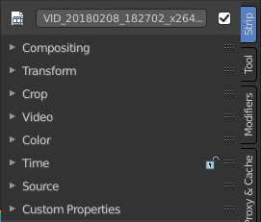
The strip tab contains all the strip type related settings. For the different strip types see the Add menu.
Some panels have the same content for all strip types. Some not. Some strip types have their own panels.

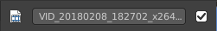
Strip tab header
In the strip tab header you will see an icon for the current strip type. The name of the strip. And a checkbox to set this strip active.
The strip can be renamed by double clicking left into the edit box.

Compositing Panel
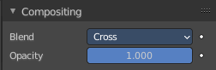

Blend
The blend method to control how the strip combines with other strips.

Opacity
How much the strip color affects other strips.

Transform Panel
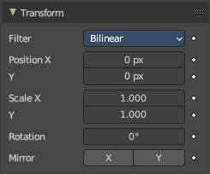

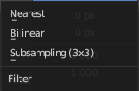
Filter
Filter type to use for transformations.

Position X
The X offset.

Y
The Y offset.

Rotation
The rotation around the image center.

Mirror
Flip on the X and/or Y axis.

Video Panel

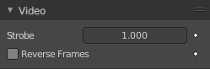
Strobe
Don't display every frame, but just every nth frame.

Reverse Frames
Reverse the frame order.

Color Panel

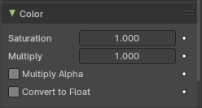
Saturation
The intensity of the input color.

Multiply
Multiply colors by this factor.

Multiply Alpha
Multiply Alpha along with color channels.

Convert to Float
Convert input to float data.

Sound Panel
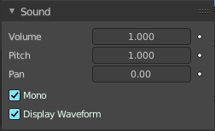
This panel shows with an audio clip selected.

Volume
The volume of the audio clip.

Pitch
The pitch of the audio clip.

Pan
When mono, the pan of the audio clip.

Mono
Set the audio clip to mono.

Display Waveform
Display the waveform in the clip.

Time Panel

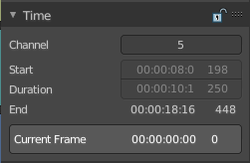
Time related settings.

Lock
Lock strip so that it cannot be transformed.

Channel
The channel of the strip.

Start
The start frame of the strip.

Duration
The duration of the strip.

End
The end frame of the strip.

Current Frame
Info box that displays the position of the frame cursor.

Scene Panel

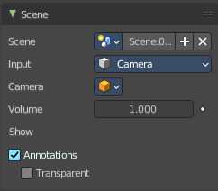
This panel just shows with strip type scene.

Scene Property

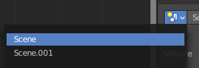
Scene Browser
A scene browser that contains the available scenes in the file.

Scene edit box
The name of the scene. It can be renamed by double clicking into the edit box.

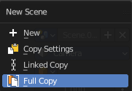
Add
Add a new scene. This button calls a menu where you can choose with what method you want to create the new scene.

New
Adds a new empty scene.

Copy Settings
Adds a new empty scene. And copies the settings from the current scene.

Linked Copy
Link in the collections from the current scene. (Shadow Copy)

Full Copy
Make a full copy of the current scene.

Remove
Remove the scene as the active one. Note that the scene is still available in the scene browser.

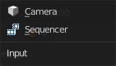
Input
Type of input to use. The camera of the scene. Or a file from the sequencer in this scene.

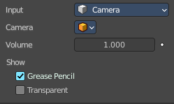
Input Type Camera

Volume
The audio volume.

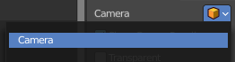
Camera
Which camera of the scene to use.

Show Grease Pencil
Show grease pencil strokes in OpenGL previews.

Transparent
Use a transparent background.

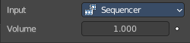
Input type Sequencer

Volume
The audio volume.

Mask Panel

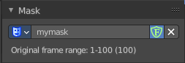
This panel just shows with strip type Mask.

Mask Property

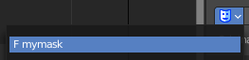
Mask Browser
A mask browser that contains the available masks in the file.

Mask edit box
The name of the scene. It can be renamed by double clicking into the edit box.

Fake User
Assign a fake user to this mask. Fake users is a odd concept to keep data in the scene even if it has no user somewhere. The fake user is then a dummy user so that the object is not deleted when saving the scene.

Remove
Remove the scene as the active one. Note that the scene is still available in the scene browser.

Effect Strip Panel
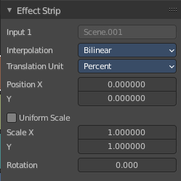
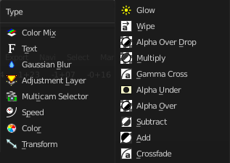
Settings for the single effect strip types.

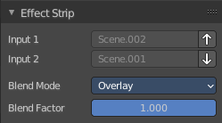
Effect strip type Color Mix

Input 1
The first strip.

Input 2
The second strip.

Swap Strips
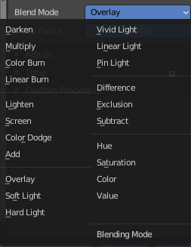
Swap the strips.

Blend Mode
The color blend mode to use.

Blend Factor
The blend factor. 1.000 means 100%.

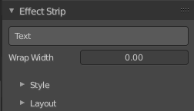
Effect strip type Text

Text
The text to displayed.

Wrap Width
World wrap width as factor. Zero disables the wrap.

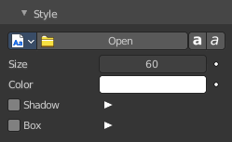
Style sub panel

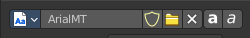
Font property
When no font is loaded then the internal font is used.

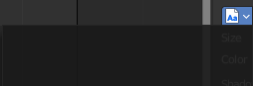
Font browser
The list of loaded fonts. This list is empty by default.

Open
Load a font.

Font Edit Box
Display the current active font. You can rename the font by double clicking in the edit box.

Fake User
Assign a fake user to this font. Fake users is an odd concept to keep data in the scene even if it has no user somewhere. The fake user is then a dummy user so that the object is not deleted when saving the scene.

Open Font
Load a font.

Remove
Remove the selected font as the active one. Note that the font is still in the list then.

Bold
Display the font bold.

Italic
Display the font italic.

Size
Size of the text.

Color
The text color.

Shadow
Creates a shadow of the specified color under the text.

Shadow color
The color of the shadow. Clicking at the color field opens a color dialog.

Box
Display colored box behind text.

Box Color
The color of the box.

Box Margin
The margin of the box. Based at the image width.

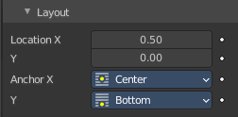
Layout sub panel

Location X/Y
Positions the text on the X, Y axis.

Anchor X/Y
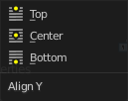
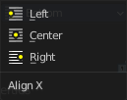
Horizontal (X) or vertical (Y) anchor point of the text relative to the location.

Effect strip type Gaussian Blur

Input 1
The strip to blur. This strip cannot be changed. You need to apply the effect with the correct strip selected.

Size X
The size of the blur along X axis.

Y
The size of the blur along Y axis.

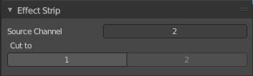
Effect strip type Multicam

Source Channel
The channel which the Multicam Selector gets its input from.

Cut to
Cuts the Multicam strip at the current frame and changes the Source Channel automatically to the selected channels.

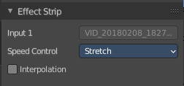
Effect strip type Speed Control

Input
The video where the speed control is applied to. This is read only.

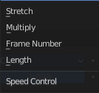
Speed Control

Stretch
Adjust input playback so that the input duration fits the strip length

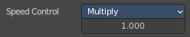
Multiply
Multiply with the speed factor.

Multiply factor
The speed factor.

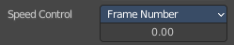
Frame Number
Frame Number of the Input strip.

Frame number
The frame number.

Length

Interpolation
Do crossfade blending between current and previous frame.

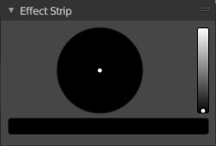
Effect strip type Color

Color Picker
Adjust the color of the color strip.

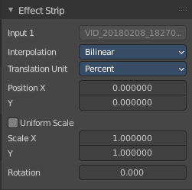
Effect strip type Transform

Input 1
The strip to transform. This strip cannot be changed. You need to apply the effect with the correct strip selected.

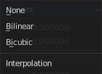
Interpolation
The interpolation type for the transform.

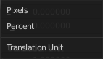
Translation Unit
The measure unit to use for the transform.

Position X
Amount to move the input in the X axis.

Y
Amount to move the input in the Y axis.

Uniform scale
Scale uniformly, preserve the aspect ratio.

Scale X
Amount to scale the input in the X axis.

Y
Amount to scale the input in the Y axis.

Rotation
Degrees to rotate the input.

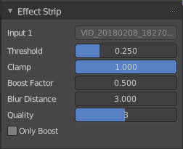
Effect strip type Glow

Input 1
The strip to use. This strip cannot be changed. You need to apply the effect with the correct strip selected.

Threshold
Minimum intensity to trigger a glow.

Clamp
The brightness limit of intensity.

Boost Factor
Brightness multiplier.

Blur Distance
The radius of the glow effect.

Quality
The accuracy of the blur effect.

Only Boost
Show the glow buffer only.

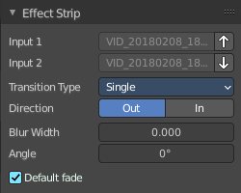
Effect strip type Wipe

Input 1
The first strip.

Input 2
The second strip.

Swap Inputs
Swap the two strips.

Transition type
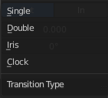
The wipe effect type.

Direction
The direction of the wipe.

Blur width
The width of the blur edge, relative to the image size.

Angle
The edge angle.

Default Fade
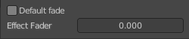
Use the builtin default effect time, which is as long as the fade clip. Or adjust the effect time.

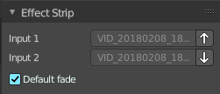
Effect strip type Alpha over Drop

Input 1
The first strip.

Input 2
The second strip.

Swap Inputs
Swap the two strips.

Default Fade
Use the builtin default effect time, which is as long as the fade clip. Or adjust the effect time.

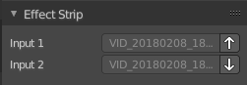
Effect strip type Multiply

Input 1
The first strip.

Input 2
The second strip.

Swap Inputs
Swap the two strips.

Effect strip type Gamma Cross

Input 1
The first strip.

Input 2
The second strip.

Swap Inputs
Swap the two strips.

Default Fade
Use the builtin default effect time, which is as long as the fade clip. Or adjust the effect time.

Effect strip type Alpha Under

Input 1
The first strip.

Input 2
The second strip.

Swap Inputs
Swap the two strips.

Default Fade
Use the builtin default effect time, which is as long as the fade clip. Or adjust the effect time.

Effect strip type Alpha Over

Input 1
The first strip.

Input 2
The second strip.

Swap Inputs
Swap the two strips.

Default Fade
Use the builtin default effect time, which is as long as the fade clip. Or adjust the effect time.

Effect strip type Subtract

Input 1
The first strip.

Input 2
The second strip.

Swap Inputs
Swap the two strips.

Effect strip type Add

Input 1
The first strip.

Input 2
The second strip.

Swap Inputs
Swap the two strips.

Effect strip type Crossfade

Input 1
The first strip.

Input 2
The second strip.

Swap Inputs
Swap the two strips.

Default Fade
Use the builtin default effect time, which is as long as the fade clip. Or adjust the effect time.

Custom Properties Panel


Here you can define custom properties that can be used for scripting.

Here you might also find custom properties from addons or scripts.

Add
Adds a new property.


Edit
Opens a panel where you can adjust the settings for the custom property.

Remove
Removes the property.

